CAPSTONE PROJECT REPORT

Electric Vehicle Market
Performance & Insights
Data Analytics and Interactive Dashboard using Tableau

Student Name | Piyush Verma
Program / Course | Data Analytics with Tableau
Project Platform | SkillWallet Capstone Project
Primary Tool | Tableau
Dataset Source | Kaggle – Electric Vehicle Market Classification Dataset

Prepared as a project documentation draft. Review all sections and add final dashboard screenshots and submission links before submitting.

Important note about the document template
The SkillWallet workspace screenshots shared during this conversation showed “No resources available,” and the required project documentation template could not be located in Overview or Workspace. This report is therefore a working draft, not a replacement for any official mandatory template. If the coordinator later provides the official template, transfer this content into that format.

1. Executive Summary
This project analyses an electric-vehicle (EV) market dataset and uses Tableau to communicate patterns in vehicle sales, manufacturers, vehicle categories, battery technologies, driving range, customer ratings and estimated environmental indicators. The intended output is an interactive dashboard supported by visualizations, a written interpretation of findings, and a demonstration video.
The supplied training file, ev_market_train.csv, contains 200,000 records and 37 fields. The sum of the annual_sales_units field is 1,550,703,961 in the dataset. These are dataset-level figures and must not be interpreted as verified real-world global EV statistics.

2. Introduction
Electric vehicles are an important part of the transition toward lower-emission transportation. The EV market includes multiple vehicle categories and battery technologies, and manufacturers compete on factors such as driving range, price, charging performance, safety, customer experience and efficiency. Analysing structured EV data can help users compare these attributes and communicate patterns that may support product planning and market research.

3. Problem Statement
EV datasets contain many attributes across vehicle models, manufacturers, regions, battery systems, sales and customer ratings. Reviewing these fields manually makes it difficult to compare categories and identify patterns efficiently. This project addresses the need for a clear, visual summary of the available dataset through Tableau charts and an interactive dashboard.

4. Project Objectives
- Explore the supplied EV dataset and understand its fields and structure.
- Prepare the data for analysis by checking field types, missing values and data consistency.
- Compare annual sales across manufacturers and vehicle categories.
- Examine battery technology distribution and vehicle driving range.
- Summarize customer ratings and selected environmental indicators.
- Build a Tableau dashboard that presents the main findings clearly.
- Document the development process and prepare a project demonstration.

5. Tools and Technologies
Tool / Technology | Purpose | Use in this project
Tableau | Data visualization and dashboarding | Connect the CSV file, create charts and assemble the dashboard.
Kaggle | Dataset source | Download the Electric Vehicle Market Classification Dataset.
CSV | Data file format | Store tabular vehicle records for Tableau analysis.
GitHub | Project versioning and sharing | Store the workbook, report, supporting files and README.
Screen recorder | Project demonstration | Record a walkthrough of the completed dashboard.

6. Dataset Description
The project uses the Kaggle dataset titled “Electric Vehicle Market Classification Dataset.” The dataset description identifies it as synthetic, meaning the records were procedurally generated for learning, classification practice and exploratory analysis. Manufacturer and model names are fictional.
Dataset file | Records / fields
ev_market_train.csv | 200,000 rows × 37 fields
ev_market_test.csv | 100,000 rows × 37 fields (available as a separate test file)
Important fields used or suitable for analysis include:
- manufacturer, model_name, model_year
- manufacturing_country, market_region, category
- battery_capacity_kwh, battery_type, battery_cycle_life
- range_km, efficiency_wh_per_km, max_dc_charging_kw
- price_usd, annual_sales_units, customer_rating
- co2_saved_tons_per_year, recommended_use_case

7. Data Collection Procedure
- Opened the Electric Vehicle Market Classification Dataset page on Kaggle.
- Reviewed the dataset description and synthetic-data notice.
- Downloaded the dataset archive.
- Extracted the archive and identified ev_market_train.csv and ev_market_test.csv.
- Selected ev_market_train.csv as the primary file for the initial Tableau analysis.

8. Data Preparation
The training CSV was connected to Tableau as a text-file data source. Tableau displayed 200,000 records and 37 fields. Field types were reviewed so that text dimensions and numeric measures could be used appropriately in visualizations.
- Categorical fields such as Manufacturer, Category, Battery Type and Manufacturing Country should be treated as dimensions.
- Numeric fields such as Annual Sales Units, Range Km, Customer Rating and Price Usd should be treated as measures.
- Price values include decimal places. The original Price Usd field should remain Number (Decimal) to preserve precision.
- A separate calculated field named Price USD whole was created using ROUND([Price Usd], 0) for cases where a whole-number display is needed. This does not change the original source field.
- Before final submission, check nulls and outliers in all fields used by the dashboard and document any exclusions or replacements.
Data-quality note: Do not replace missing values with zero unless there is a valid business reason. A missing value and a true zero have different meanings.

9. Data Analysis and Visualizations
The following visualization plan is suitable for the available EV fields. Retain only the charts that are actually present in the final Tableau workbook and add screenshots after the dashboard is complete.
Visualization | Suggested fields / calculation | Purpose
Sales by Manufacturer | Manufacturer; SUM(Annual Sales Units) | Compare sales totals across manufacturers.
Sales by Vehicle Category | Category; SUM(Annual Sales Units) | Identify categories with higher sales totals.
Battery Technology Distribution | Battery Type; COUNTD(Vehicle Id) or record count | Compare the number of records by battery type.
Average Driving Range by Category | Category; AVG(Range Km) | Compare typical range across vehicle categories.
Customer Rating by Category / Manufacturer | Category or Manufacturer; AVG(Customer Rating) | Compare average customer ratings.
Manufacturing Country Analysis | Manufacturing Country; COUNTD(Vehicle Id) or SUM(Annual Sales Units) | Explore country-level distribution in the dataset.
CO₂ Savings by Category | Category; AVG or SUM(CO₂ Saved Tons Per Year) | Compare the dataset's estimated CO₂-saving measure.

10. Tableau Dashboard Development
- Create separate worksheets for each required chart or KPI.
- Use clear titles, readable labels and consistent number formatting.
- Arrange the worksheets on a Tableau Dashboard with an executive summary at the top.
- Add filters only where they help users explore the data, such as Category, Battery Type, Manufacturer or Manufacturing Country.
- Test filter interactions and ensure that charts update as expected.
- Add a short note that the dataset is synthetic.

Final Tableau Dashboard

11. Key Findings / Story Points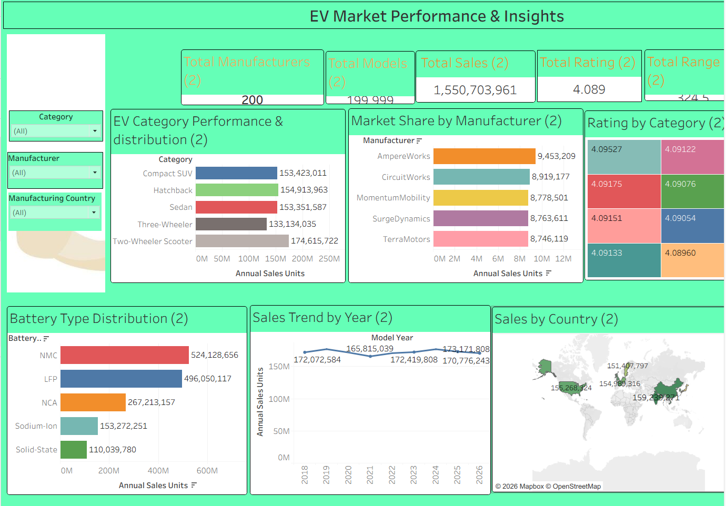
- Sales by manufacturer: AmpereWorks has the highest total annual_sales_units in the training file at 9,453,209.
- Vehicle category: Two-Wheeler Scooter has the highest category sales total in the training file at 174,615,722.
- Battery mix: NMC is the most frequent battery type in the training file (33.8% of records), followed by LFP (32.0%).
- Driving range: Luxury Sedan has the highest average range among categories at 550.6 km.
- Customer rating and environment: The overall mean customer rating is 4.09/5. Electric Bus has the highest category-average co2_saved_tons_per_year in this file (9.03 tons/year).
Interpretation caution: These statements describe the supplied synthetic training dataset only. They are not evidence of actual manufacturer market share, actual global sales, or measured real-world emissions reductions.

12. Testing and Validation
- Confirm that the Tableau workbook opens and the data source refreshes successfully.
- Check that sales measures use SUM and average metrics use AVG where appropriate.
- Check that vehicle counts use COUNTD(Vehicle Id) if unique vehicles are intended.
- Verify that filters and dashboard actions work correctly.
- Check titles, units, number formats, legends and tooltips for clarity.
- Compare selected chart totals with summary calculations from the source data.
- Capture screenshots of the final dashboard and important story points.

13. Conclusion
The project demonstrates how a structured electric-vehicle dataset can be explored and presented using Tableau. The analysis focuses on sales, vehicle categories, battery technologies, driving range, customer ratings and an estimated environmental indicator. The resulting dashboard is intended to make these dimensions easier to compare and to communicate the main patterns in a concise visual format. Because the dataset is synthetic, conclusions should be limited to the dataset and should not be generalized to the real EV market.

14. Project Deliverables and Submission Links
Deliverable | Status | Link / location
Tableau workbook (.twb / .twbx) | To verify | [Insert file name or repository path]
Dataset file(s) | Available locally | [Insert repository path; check dataset licence/terms]
Project report | Draft created | [Insert final report path]
GitHub repository | To complete | https://github.com/en25cs3010676-source/ev_market_dashboard
Demo video | To record | [Paste accessible video URL]
Final dashboard screenshots | To add | [Insert screenshot path]

15. Final Review Checklist
- ☐ Transfer this content into the official SkillWallet template if it becomes available.
- ☐ Confirm that every visualization described in this report exists in the final workbook.
- ☐ Insert screenshots of the actual Tableau worksheets, dashboard and story.
- ☐ Update the report with any real filters, calculated fields and testing performed.
- ☐ Add the GitHub repository URL and demo video URL.
- ☐ Check the Kaggle dataset licence and project rules before redistributing the raw dataset publicly.
- ☐ Submit the report and links through SkillWallet as instructed.
Figure 1. Electric Vehicle Market Performance & Insights dashboard created in Tableau.
The dashboard includes KPI cards for total manufacturers, total models, total sales, average rating and average range; filters for category, manufacturer and manufacturing country; and charts for category performance, manufacturer market share, category ratings, battery-type distribution, sales trend by model year and sales by country.

